**Lecture 7- Validity, Reliability and Gantt Chart**

## Validity

**Validity** refers to the “truth” of the author’s interpretation of the research material – are the findings really about what they appear about? So validity is the extent to which;

Data collection method(s) accurately measure what they were intended to measure, and

The research findings are really about what they profess to be about.

The author must attempt to understand and eliminate all factors that threaten the validity of the research.

Validity can relate to internal and external factors. The internal factors are shown below:

|  |  |
| --- | --- |
| ***Factor*** | ***Refers to:*** |
| Subject selection | The biases which may result in selection of particular research subjects which may be unrepresentative of the research population |
| History | Specific events which occur in the history of the project (e.g. between 1st. and 2nd Phases of the research) which have an important effect on the findings |
| Testing | Any effects that the data collection process itself may have on the subjects (e.g. respondents keen to impress the interviewer) |
| Mortality | The loss of subjects during the research – particularly if a longitudinal study is undertaken |
| Ambiguity over causal direction | Confusion over cause and effect (e.g. are poor call centre operator performance ratings caused by a negative attitude towards the way their performance was rated, or were the poor ratings causing the negative attitude) |

External factors relate the degree to which the conclusions are generalisable to other research settings. If the research has been undertaken in one organisation is it valid to claim the findings apply to others? This problem would be solved by including other organisations of course. It may be that you are not concerned with making a generalisation and want only an explanation of what is going on in the particular research setting – this is fine of course.

## Reliability

Reliability is the degree to which the measure of a construct is consistent or dependable. In other words, if we use this scale to measure the same construct multiple times, do we get pretty much the same result every time. In other words, **Reliability** is the extent to which data collection methods and data analysis procedures produces consistent findings. So:

* Would the measures produce the same results if used on other occasions?
* Would other researchers, using the same methods and procedures, produce similar results?
* Would those interpreting your results clearly see how the conclusions of the research were reached?

The factors which can threaten reliability are shown below:

|  |  |
| --- | --- |
| ***Factor*** | ***Refers to:*** |
| Subject error | Measurement that takes place at different times (e.g. a survey administered to night-shift workers may produce different results to day-shift workers) |
| Subject bias | Subjects giving unreliable information (e.g. they may think telling the truth may show them in a bad light). |
| Observer error | The way in which different researchers may, for example, ask the same questions in different manners, so biasing the results. |
| Observer bias | The way in which different researchers may interpret the same data in different ways, thus biasing the findings and conclusions |

**Study the example given below,**

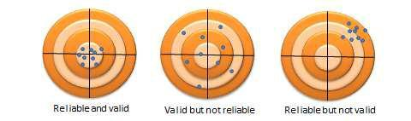

**Watch the video on the difference between Reliability and Validity**

[**https://youtu.be/aEoL5g6HNsI**](https://youtu.be/aEoL5g6HNsI) **( beginners)**

[**https://youtu.be/2fK1ClycBTM**](https://youtu.be/2fK1ClycBTM) **( advanced)**

**Example of Gantt chart**

**Example of a (Simple) Gantt chart** : to be included in your proposal, however note that the tasks will be actually your own research processes- starting from finalising the topic and the research questions to submitting the final project report.

Note that the tasks are based on your research processes – like refining your research questions, reviewing literature, planning the data collection, analysing the data, discussing the results, collating the findings, documenting the report, submission etc.

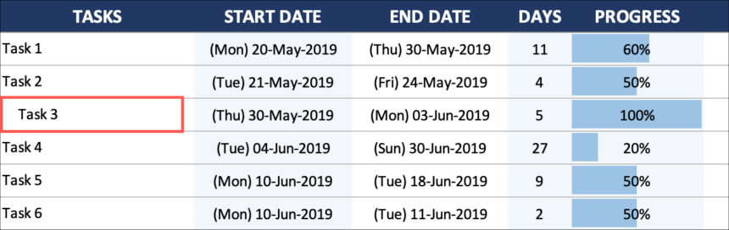

Sample Gantt chart from an Assignment

